Greater Des Moines Softball Hall of Fame

Meeting September 9, 2014

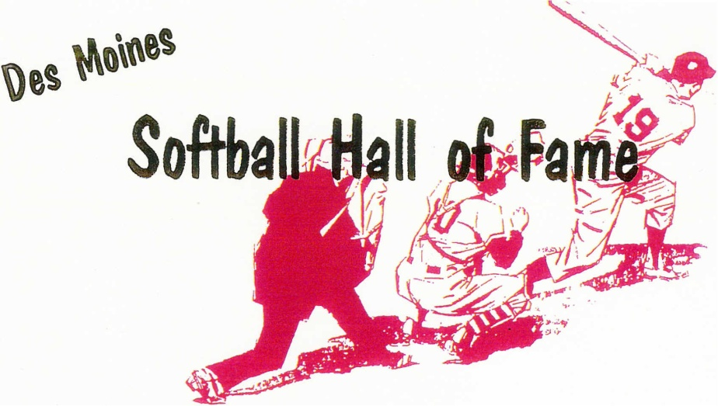
Pres. Mike Clark
VP. Chuck Welker
Sec. Tony Nelson
Treas. Kevin Walker

dmfastpitch@hotmail.com

Meeting held on September 9, 2014 Call to order: 7:02 PM

Meeting attended by 21 members:
Roger Aceto, Don Bailey, Gordy Baker, Gary Christensen, Mike Clark, George Davis, Mike Fuller, Robert Mahaffey, Tony Nelson, Al Van Dyke, Kevin Walker, Chuck Welker, Lou Yacinich Jr. Steve Corkrean, Tom Bakey, Sammy Allgeier, Dick Kimm, Alex Quijano, Henry Quijano, Dennis Linderbaum, Ray Quijano

Minutes for May 13, 2014 meeting were approved as read - unanimous

Kevin Walker gave treasurer's report.
- Donations of $110 were collected during the May meeting for the Hilltop food bill. Gordy Baker paid our last bill to Hilltop – Big Thank You.
- Ray Nissly passed away August 19, 2014 – A donation of $50 was made to the National Hemophilia Foundation as instructed by the family.
- All bills are paid: the current balance is $833.45
- Treasurer’s report approved as read - unanimous

Old Business :
Resumes being sought out for future consideration:
- Dennis Geisford – Roger Aceto has had no luck getting a resume from Dennis.
- Donny Ramus – Chuck Welker has had no luck getting a resume from Donny.
- Jeff Wilson – Gordy Baker has had no luck getting a resume from Jeff.

New Business:
Read resumes for the following candidates – Chris Bigelow, Ron Fontana, Dick Henry, Anthony Palazzo, Randy Vanderwaal

Voting results of candidates: ** A majority vote of 11 or more is needed for acceptance into the HOF **
- Chris Bigelow - 8
- Ron Fontana - 17
- Dick Henry - 14
- Anthony “Tony” Palazzo - 19
- Randy “Slim” Vanderwaal – 16

Ron Fontana, Dick Henry, Anthony “Tony” Palazzo and Randy “Slim” Vanderwaal were accepted into the DM HALL OF FAME.

Election of officers
- President – (Henry Quijano –nominates George Davis. George Davis declines to run). Mike Fuller nominates Mike Clark to continue as President. Denny Linderbaum with the 2nd. All in favor with one nay vote.
- Vice President – Denny Linderbaum nominates Chuck Welker to continue as VP. Gordy Baker with the 2nd. Unanimous vote.
- Secretary – Lou Yacinich nominates Tony Nelson to remain as Secretary. Denny Linderbaum with the 2nd. Unanimous vote.
- Treasurer – Gordy Baker nominates Kevin Walker to remain as Treasurer. Al VanDyke with the 2nd. All in favor with one nay vote. ; )

A Motion by Gary Christensen was presented to amend the By-Laws for how future resumes will be screened and presented for a vote. The new process will now read “ALL qualified/valid resumes that are presented to the active membership will be read and voted upon during the September meeting”. This would replace the existing process for accepting the resumes and putting them thru a screening process by the executive board. George Davis second. A 2/3 vote is needed by the active membership in two consecutive meetings for the By-Law to be changed. This motion would need 13 votes during this meeting to pass since Don Bailey and Roger Aceto left prior to the motion/vote. The vote was held and we had 14 votes in favor of the motion. This motion will be presented again at the May 2015 meeting for a second round of voting. We will need a 2/3 vote from the active membership at the May meeting for the motion to carry and the By-Laws be amended.

Note: If you are an active member (have attended one meeting in the last 12 months) – you can cast a vote for the May meeting by sending an email to dmfastpitch@hotmail.com - this would be considered a proxy vote.

Motion by George Davis to put one more candidate on the ballot tonight and call for a revote…that motion was declined.

Meeting was adjourned at 8:37 PM

